CLOUD COMPUTING CONDING CONTEST 1

ABINAYA S

727721EUIT002

[727721euit002@skcet.ac.in](mailto:727721euit002@skcet.ac.in)

Question 1

CREATE A EC2 INSTANCE IN THE us-east 1 region with the following:

1. Instance name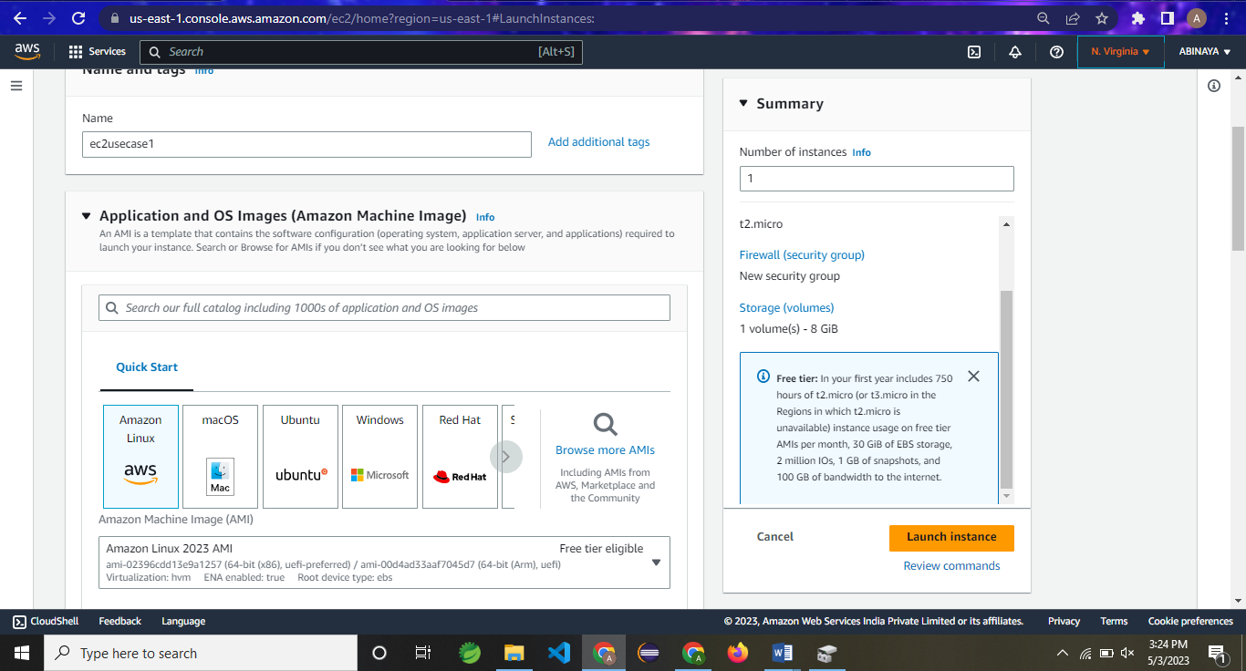

Keypair name

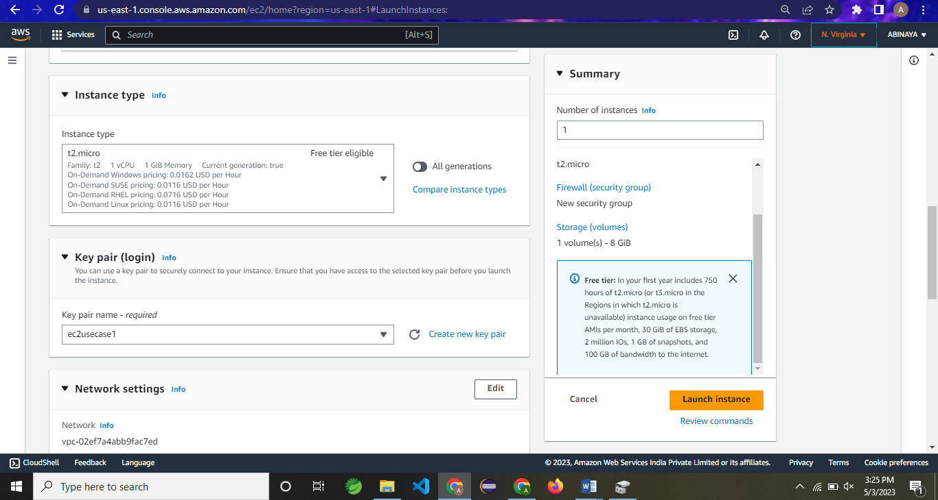

ii)Amazon Linux selected



iii)SSH ACCESS

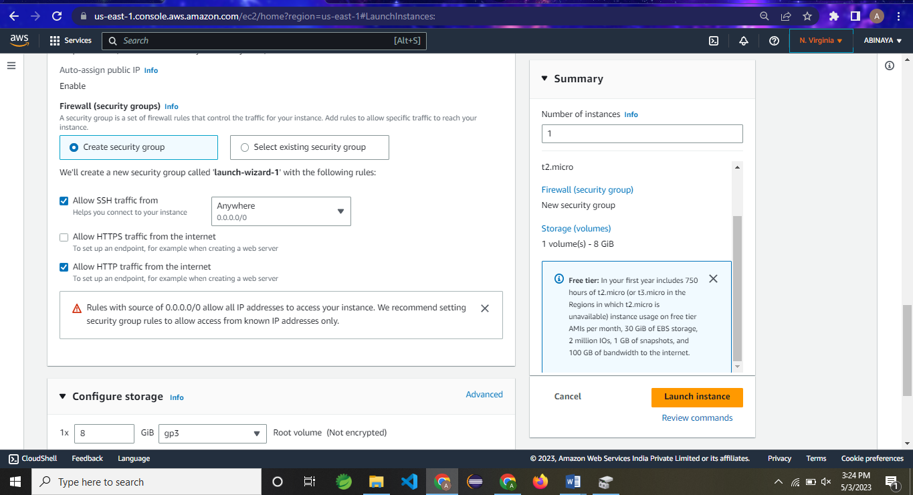

iv)HTTP ACCESS

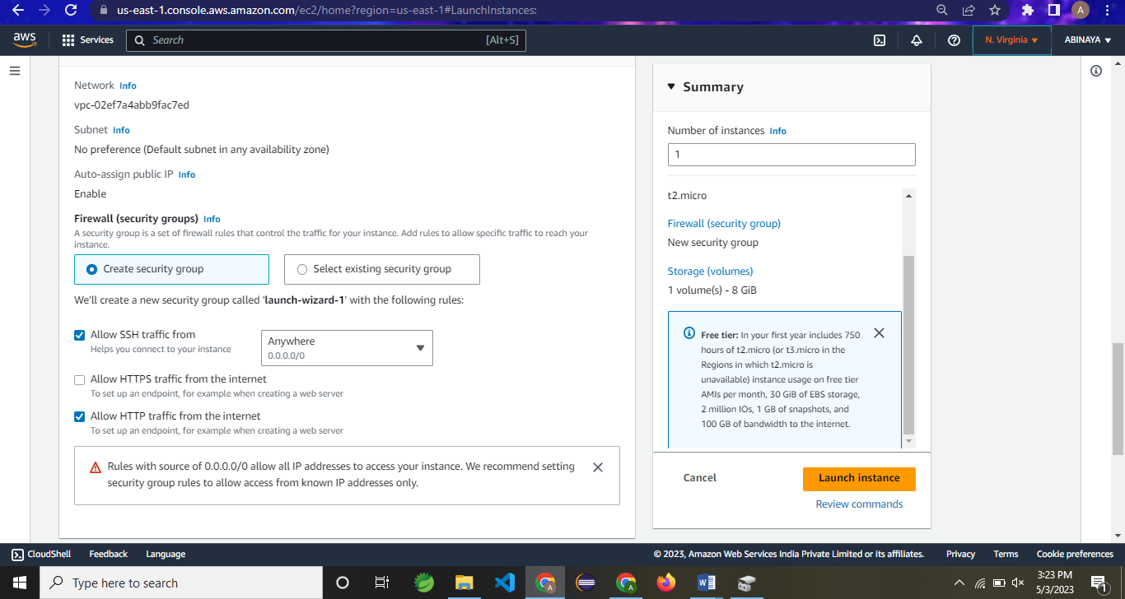

INSTANCE SUCCESS STATUS

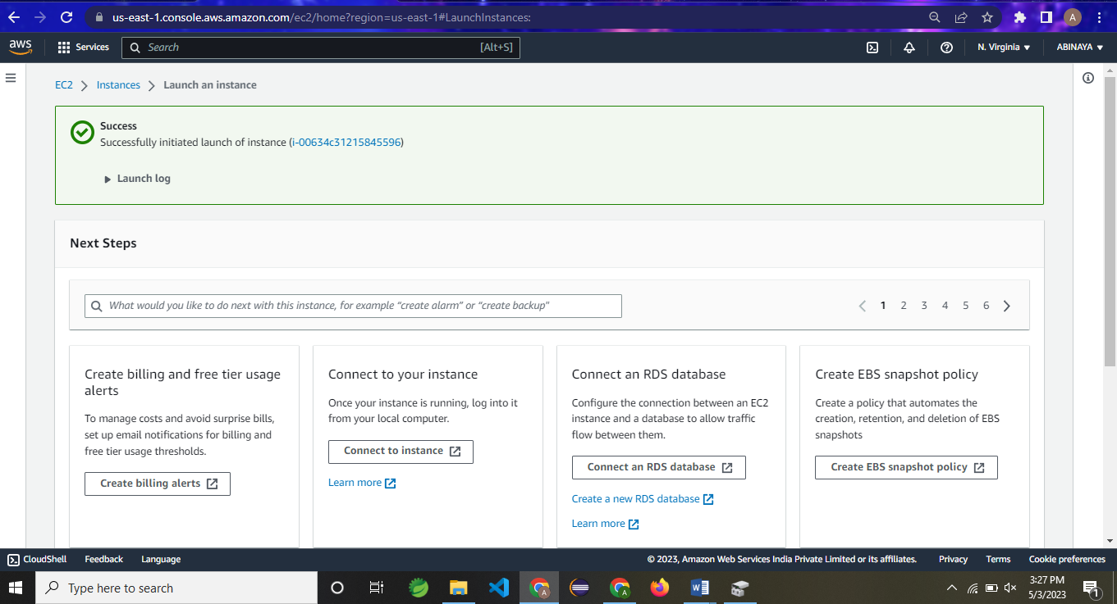

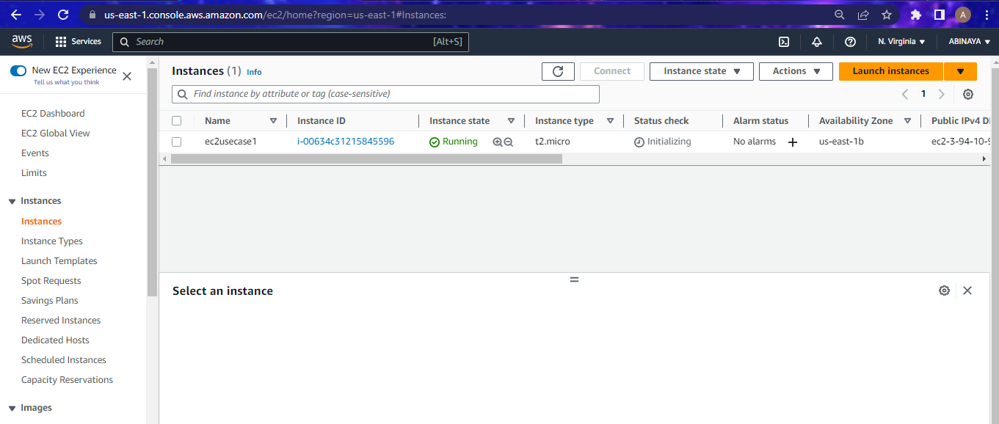

QUESTION 2

CREATE A IAM GROUP AND USER ADD SOME POLICIES.

1. GroupName

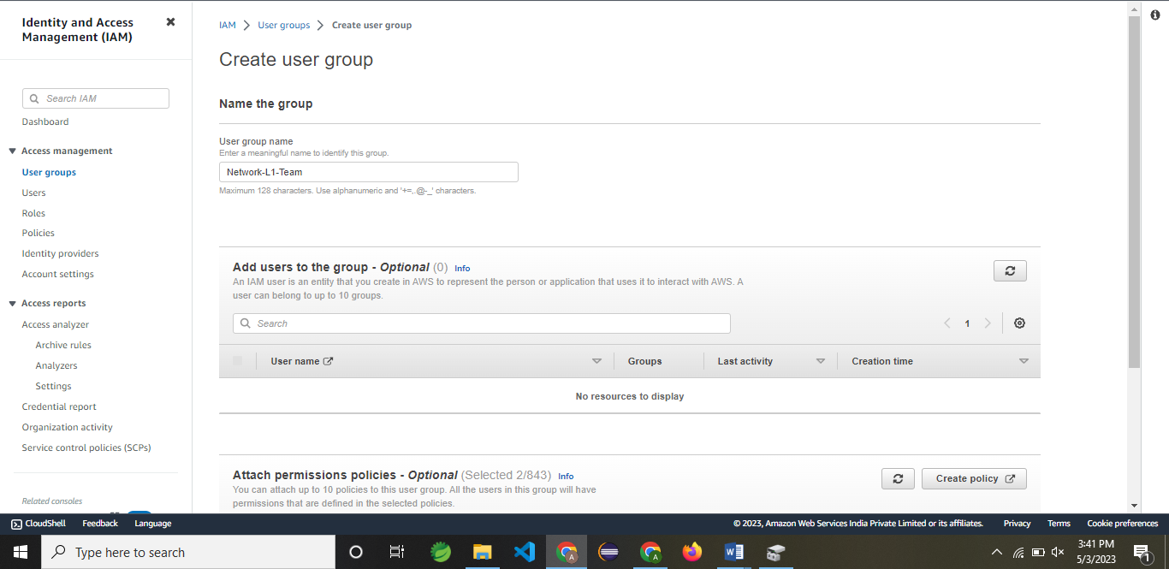

ii)Users

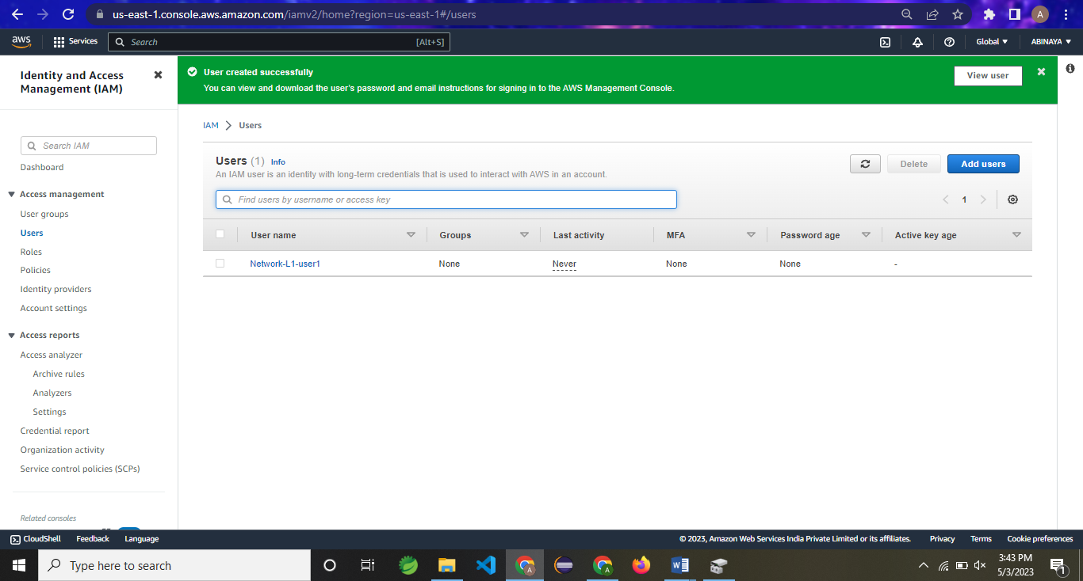

1. Adding a polices

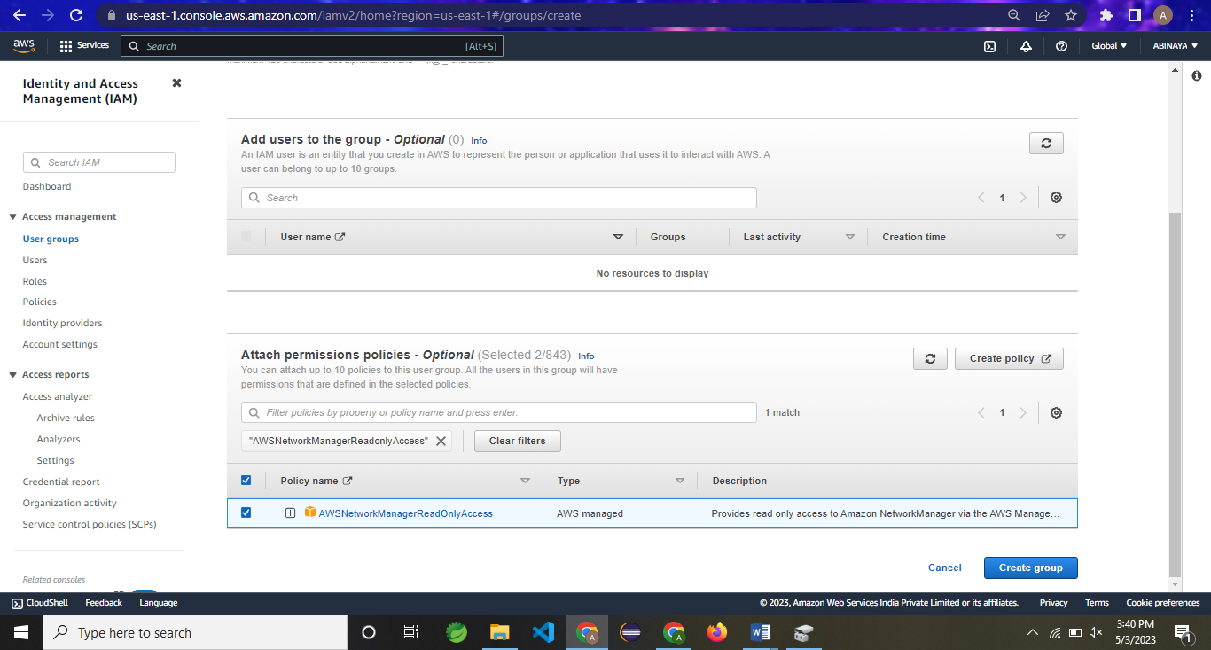

1. Policy added

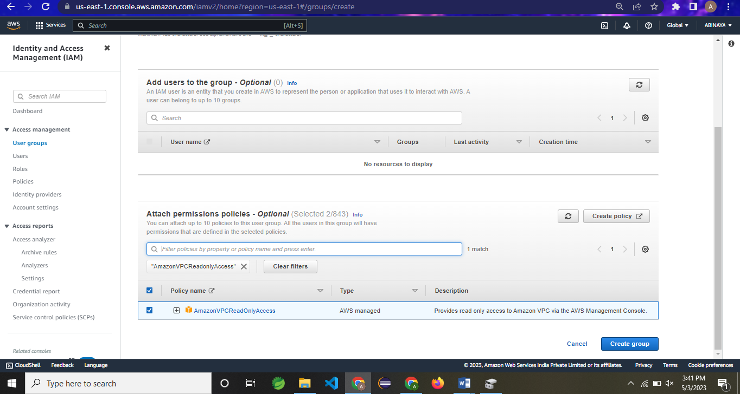

Overall group created..(Screen shot)

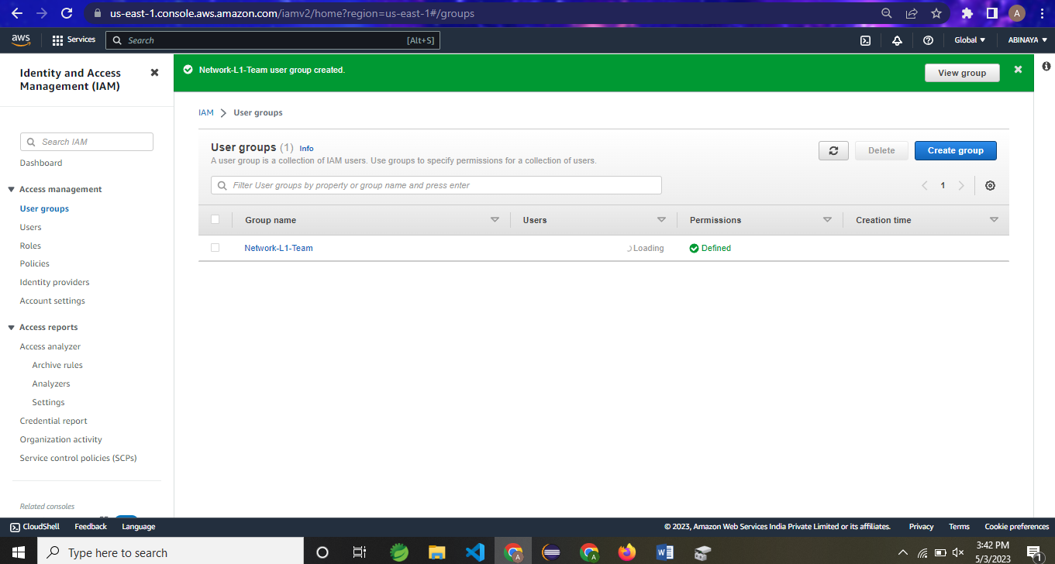

QUESTION 3

Create a S3 bucket for the following requirements.

i)

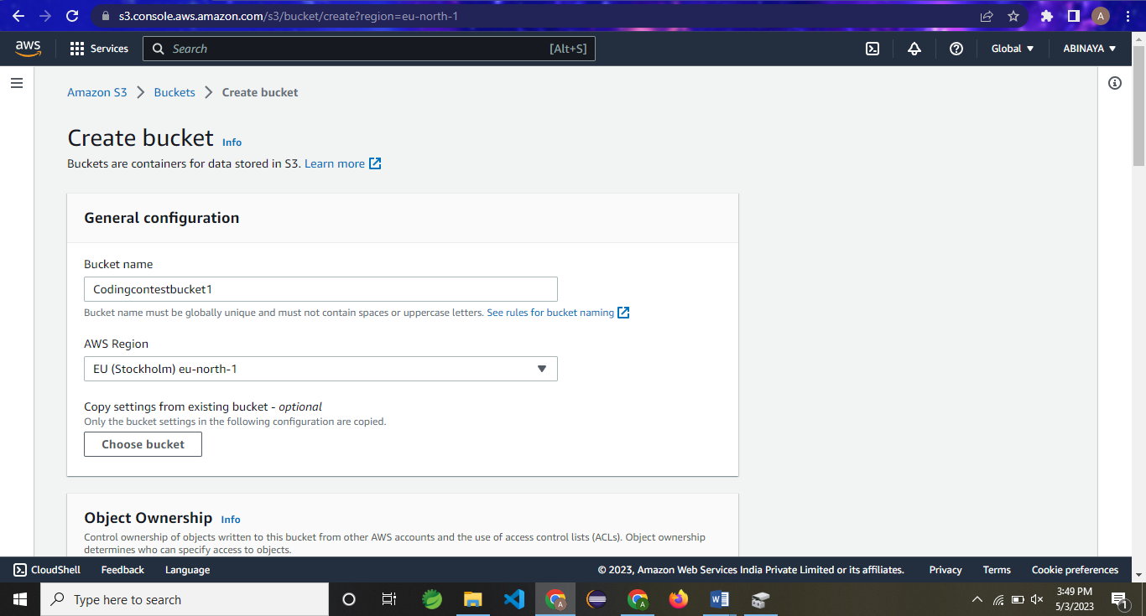

ii)

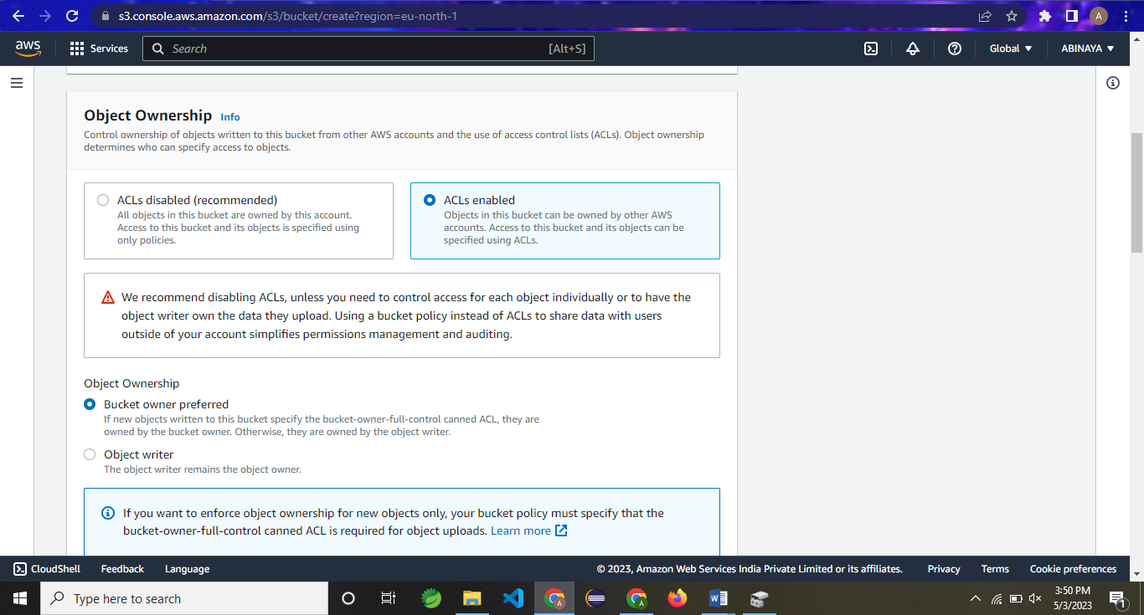

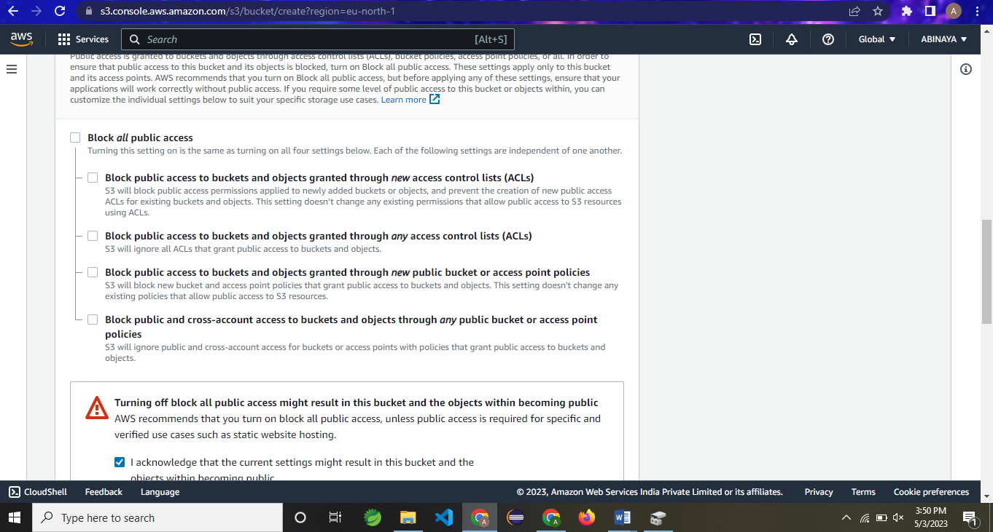

Bucket is created..

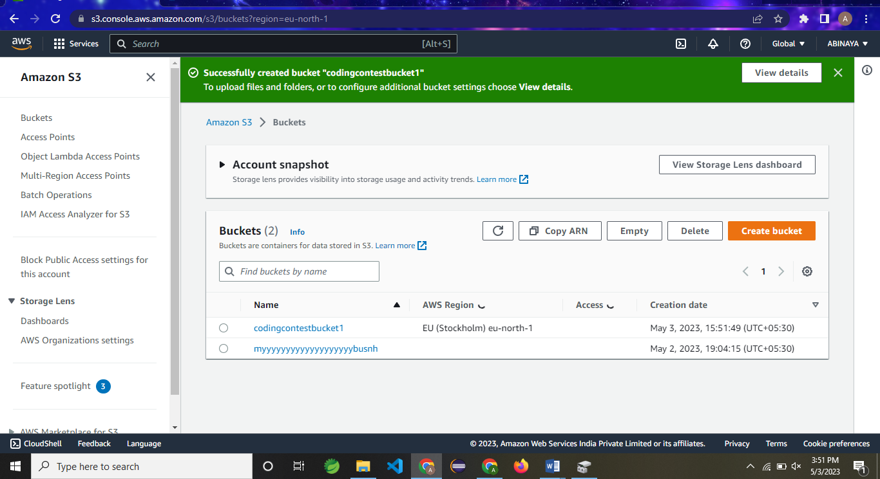

iii)Upload a files

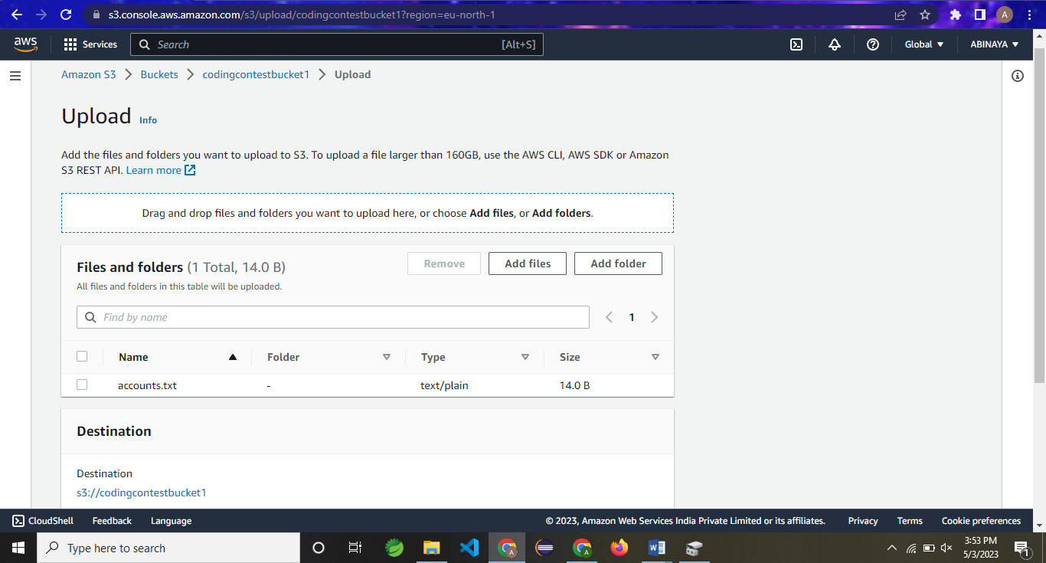

iv)Make a public access

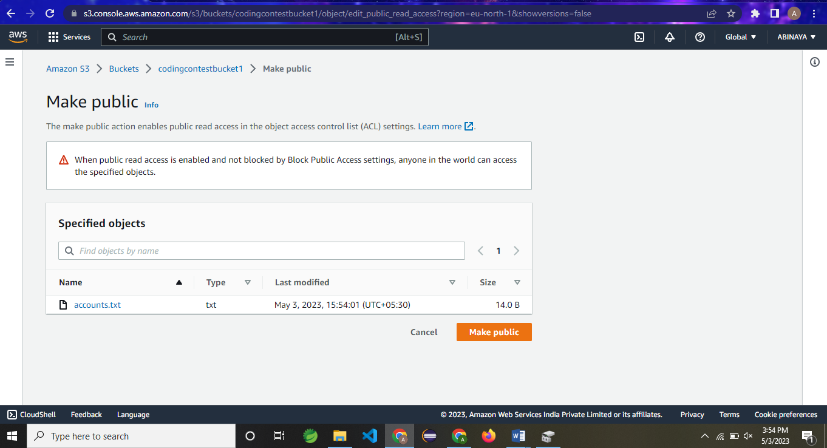

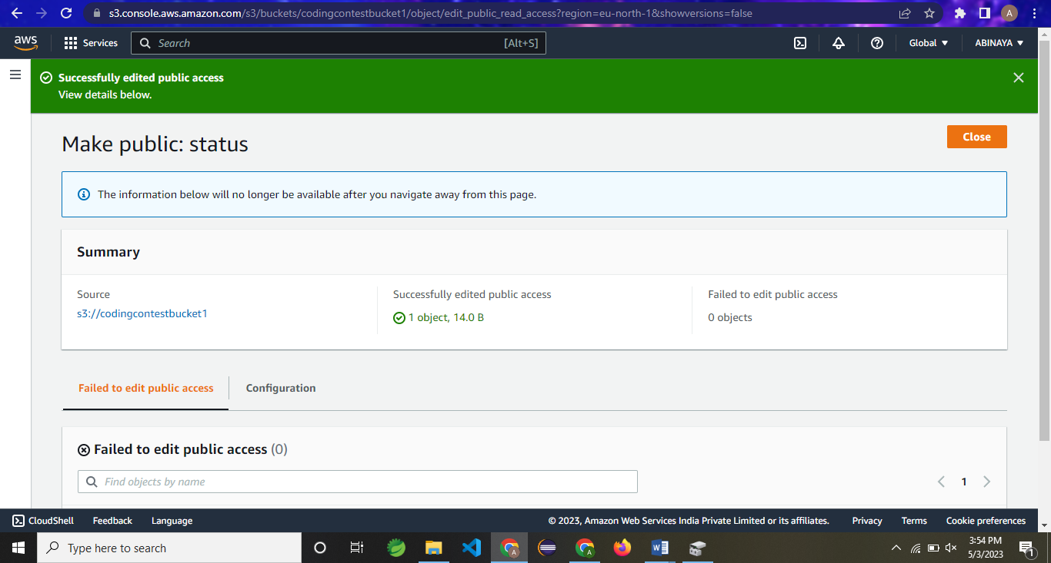

OUTPUT:

